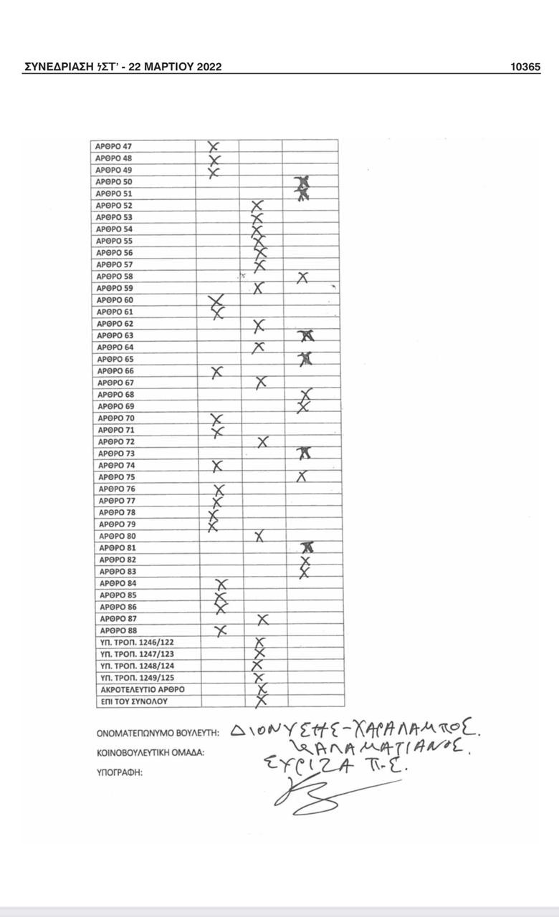
https://www.hellenicparliament.gr/UserFiles/a08fc2dd-61a9-4a83-b09a-09f4c564609d/es20220322.pdf

